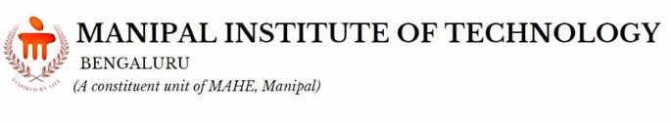
School of Computer Engineering
Machine Learning Lab (CSE_3146)
Mini Project Proposal
Student Name & Reg. No:
Vinayak Sharma(Student 1)
Mohd. Zafar(Student 2)
(Student 3)
Dept/Branch:
3rd year Ai-B

Project Title:
Twitter Sentiment Analysis
(Write your project title here – should be concise and descriptive.)

- Background / Motivation:
The immense volume of digital conversations on Twitter makes it challenging to understand public sentiment. This project aims to transform this raw data into meaningful insights, revealing the hidden emotional currents that impact brand perception and market trends.
(Briefly state the problem, gap, or motivation behind choosing the project)
- Objectives:
1: To develop a model that accurately classifies individual tweets as positive, negative, or neutral.
2: To visualize sentiment trends over a specific period, allowing for real-time analysis of public opinion.
3: To identify the key topics or events driving shifts in sentiment.
(State 1 to 3 objectives that are clear, focused, and achievable within the limited scope)
- Proposed Methodology / Approach:
We will collect and clean a dataset of tweets using the Twitter API. We plan to experiment with machine learning models like Naive Bayes and a deep learning model like BERT, selecting the best-performing model based on accuracy and other metrics.
(Summarize the methods, algorithms, or tools you plan to use. Mention datasets, software, or experimental setup.)
- Expected Outcomes / Scope:
The primary deliverables will be a highly accurate sentiment classification model and an interactive data visualization dashboard. This dashboard will display sentiment trends over time and highlight influential keywords, providing a clear, actionable summary of the social media landscape.
(Summarize what you expect the project to deliver, i.e, deliverables of your project).
Keywords: (3–5 important terms related to your project, e.g., Machine Learning, Fraud Detection, Random Forest, Classification)

